**Educational Game Design Project (Name in Progress)**

Project Members:

Josh Selmser, Steven Dull

**Target Date**: April 29th, 2013

**Genre**: Retro, Space-Themed

**Introduction**: This game is to be a puzzle platformer where you collect items with different conductive properties to demonstrate, teach, and show an understanding of insulators and conductors.

**Purpose**: The user will visually be able to see how different conductors and insulators affect electric flow. By using different items they pick up, the user will manipulate the flow of electricity to power doors, elevators, and other mechanisms.

**Back Story**: You play a robot that has been brought online by the main computer to restore the facility back to its functioning state.

**Description of Interaction**: You will start at the beginning of a level, having no items in your possession. As you navigate obstacles, you will collect different conductors and insulators to place in electrical devices along the way. This allows you to manipulate the environment by slowing and/ or stopping the flow of electricity to objects such as doors, or increasing the flow to power an elevator. The user will be given a volt meter and possibly a calculator to help him or her experiment on the items and devices in the game.

**Key Features**:

* Manipulate electricity with different items!
* Electrical objects such as conveyor belts, elevators, and smashy-angry blocks!
* Useable items such as a volt meter and a calculator
* Information screens with hints
* Visible wires with observable currents!

**Target Platforms**: PC Web Flash Game, using C# and Silverlight

Intended Audience: Designed with the classroom in mind! This game is meant to educate and to be fun at the same time! It is intended to be distributed to teachers and parents who would like their kids to learn about current and conductivity. The content of this game is geared towards 8th graders.

**Length of Play**: 10 – 15 minutes a session

**Art Assets**:

* Still background, one level at a time
* Still objects
  + Platforms
  + Retro-space objects
  + Non-animated moving objects
* Animated objects
* Conveyer belts
* Doors
* Elevators
* Main character
* Particles
* Sparks
* Smoke from shorts
* Current
* User interface
* Title screen and credits
* Inventory of conductive items
* Hint screens
* Volt meter and calculator
* Music
* Title screen theme song
* In-game song or two
* Sound Effects
* Sparks
* Electrical sounds
* Generator Sounds
* Robot noises
* 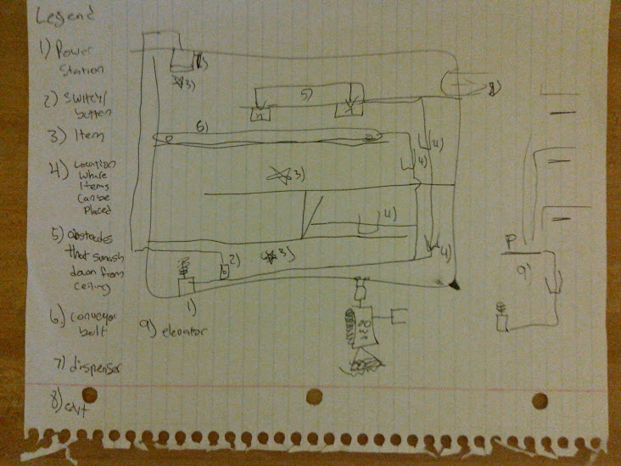Conveyor and smasher sounds